Project Design Phase-II
Data Flow Diagram & User Stories

Date | 31 January 2025
Team ID | LTVIP2026TMIDS68930
Project Name | Asset Management Portal
Maximum Marks | 4 Marks

Data Flow Diagrams:
A Data Flow Diagram (DFD) is a traditional visual representation of the information flows within a system. A neat and clear DFD can depict the right amount of the system requirement graphically. It shows how data enters and leaves the system, what changes the information, and where data is stored.
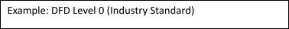
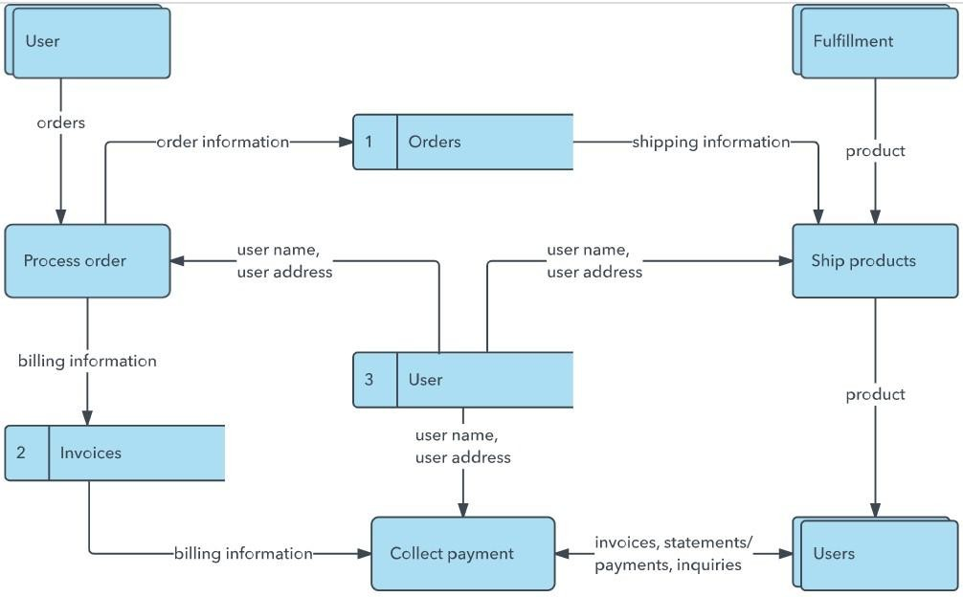
Example: (Simplified)
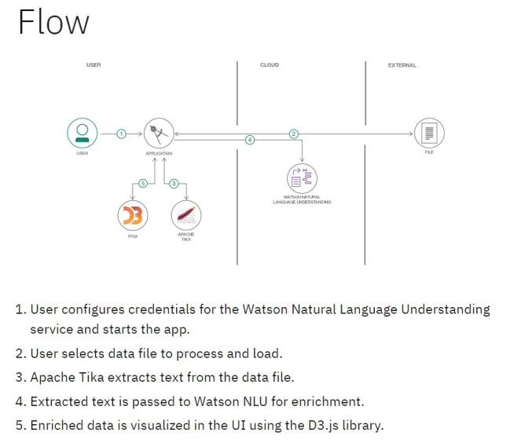

User Stories
Use the below template to list all the user stories for the product.
User Type | Functional  Requirement  (Epic) | User Story  Number | User Story / Task | Acceptance criteria | Priority | Release
Customer  (Mobile user) | Registration | USN-1 | As a user, I can register for the application by entering my email, password, and confirming my password. | I can access my account / dashboard | High | Sprint-1
Customer  (Mobile user) | Registration | USN-2 | As a user, I will receive confirmation email once I have registered for the application | I can receive confirmation email & click confirm | High | Sprint-1
Customer  (Mobile user) | Registration | USN-3 | As a user, I can register for the application through Facebook | I can register & access the dashboard with Facebook Login | Low | Sprint-2
User Type | Functional  Requirement  (Epic) | User Story  Number | User Story / Task | Acceptance criteria | Priority | Release
Customer  (Mobile user) | Registration | USN-4 | As a user, I can register for the application through Gmail | I can register & access the dashboard using Gmail login. | Medium | Sprint-1
Customer  (Mobile user) | Login | USN-5 | As a user, I can log into the application by entering email & password | I can successfully log in and access the dashboard. | High | Sprint-1
Customer  (Mobile user) | Dashboard | USN-6 | As a user, I can view my profile and application details in the dashboard. | I can see my profile info and recent activities. | High | Sprint-2
Customer (Web user) | Registration | USN-7 | As a user, I can view my profile and application details in the dashboard | I can access my web dashboard after registration. | High | Sprint-1
Customer Care Executive | Login | USN-8 | As a web user, I can log into the website using email & password. | I can access my account from web browser. | High | Sprint-1
Administrator | Dashboard | USN-9 | As a web user, I can view and manage my acc | I can update profile and  ount details.  view activities. | Medium | Sprint-2
Customer Care Executive | User Management | USN-10 | As a customer care executive, I can view custo | I can search and view  mer details. customer information. | High | Sprint-2
Customer Care Executive | Issue  Management | USN-11 | As a customer care executive, I can respond to customer queries. | I can update query status and send response. | High | Sprint-2
Administrator | Admin Login | USN-12 | As an administrator, I can log into the admin panel. | I can securely access the admin dashboard. | High | Sprint-1

